**Homework 2: Route Finding**

**Report Template**

**Part I. Implementation (6%):**

* **Part 1 BFS**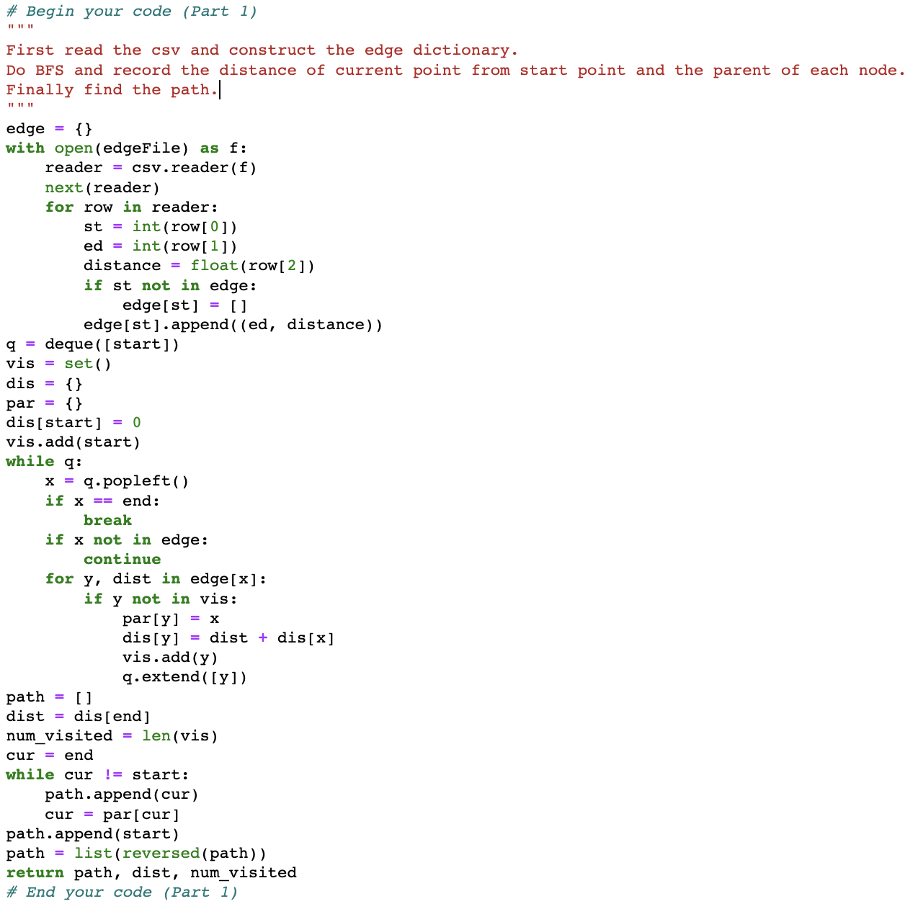
* **Part 2   
  DFS(stack):**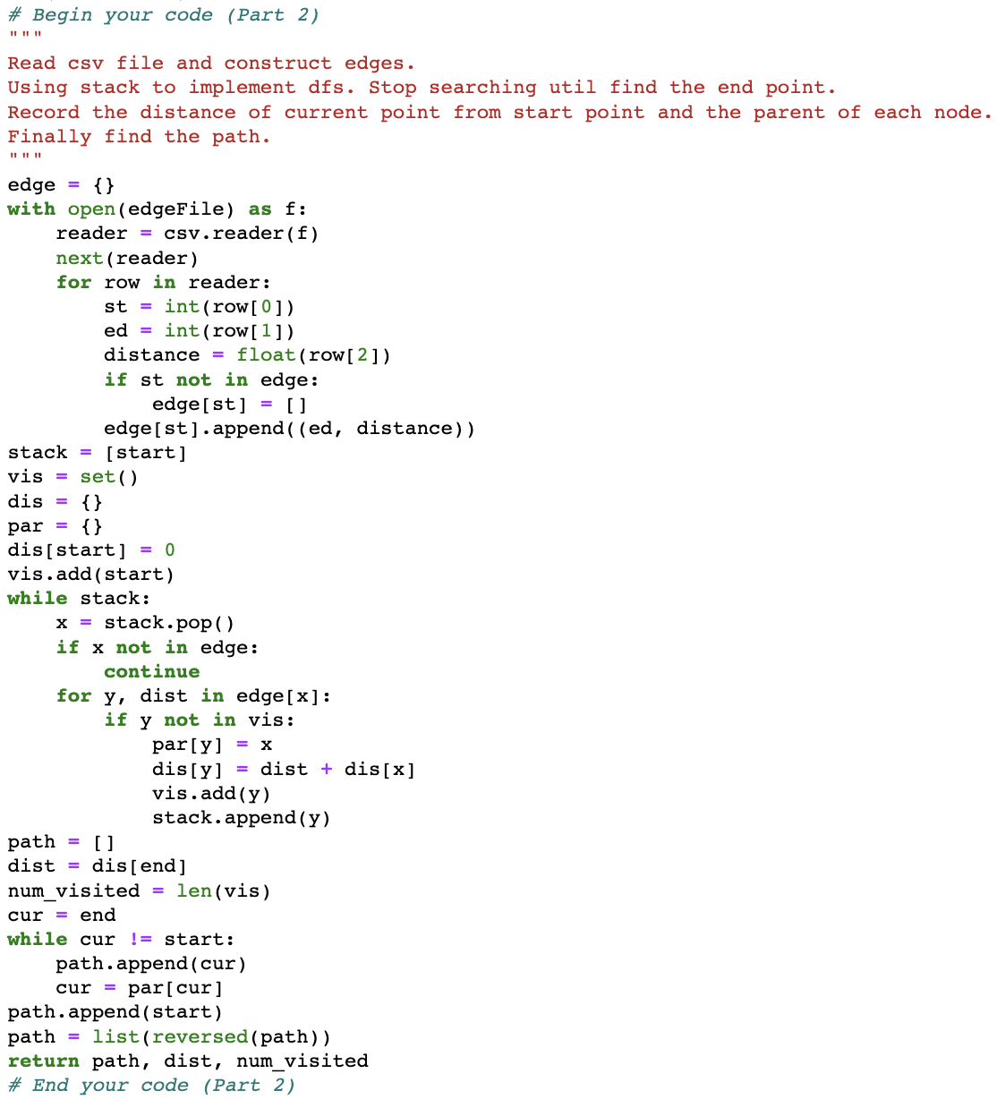

**DFS(Recursive):  
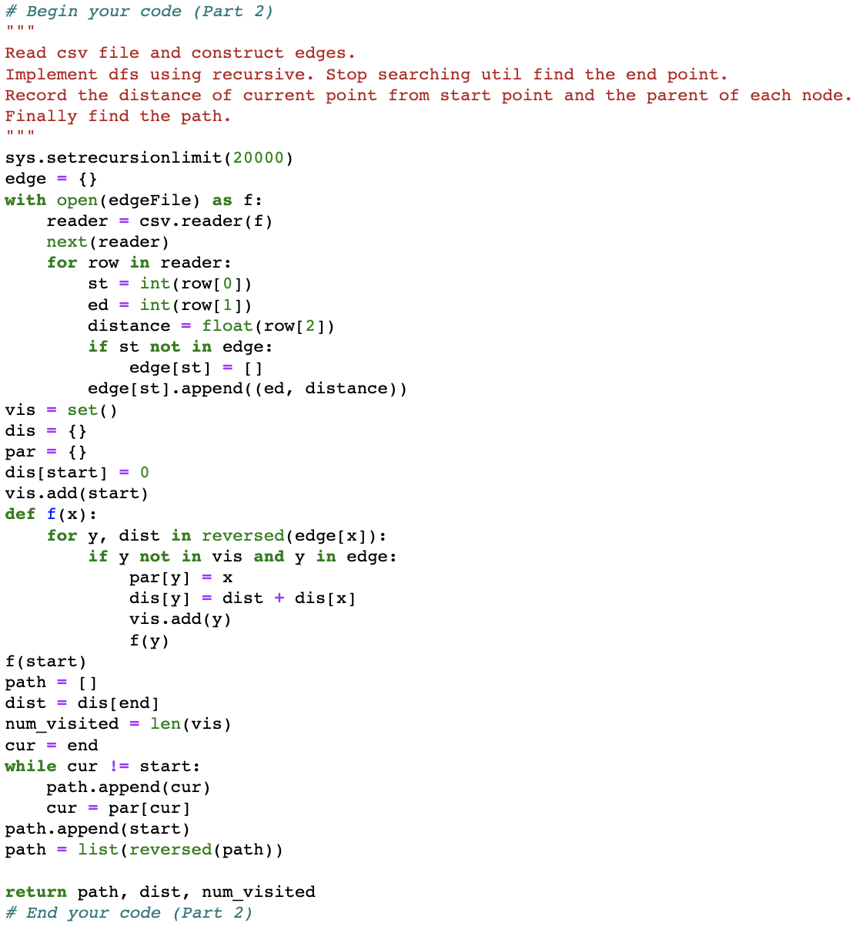**

* **Part 3 UCS  
  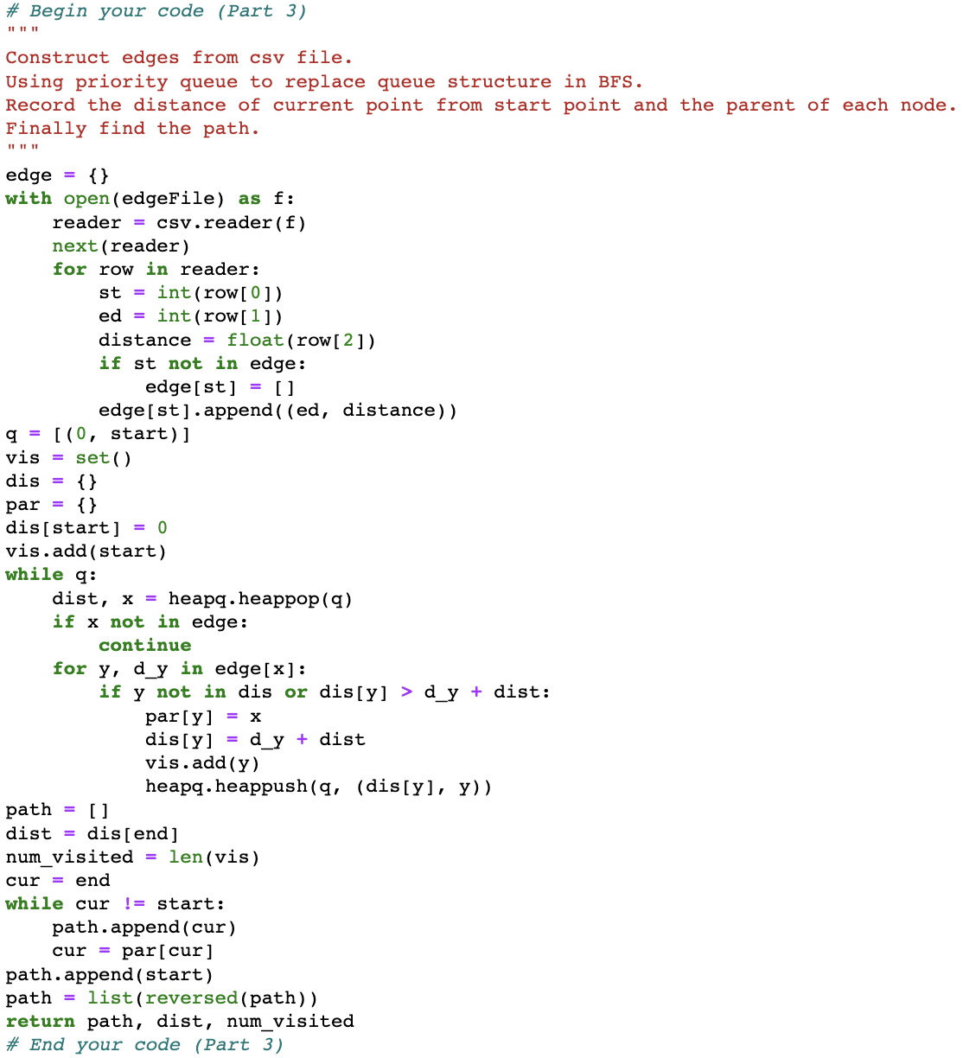**
* **Part 4 A* Search**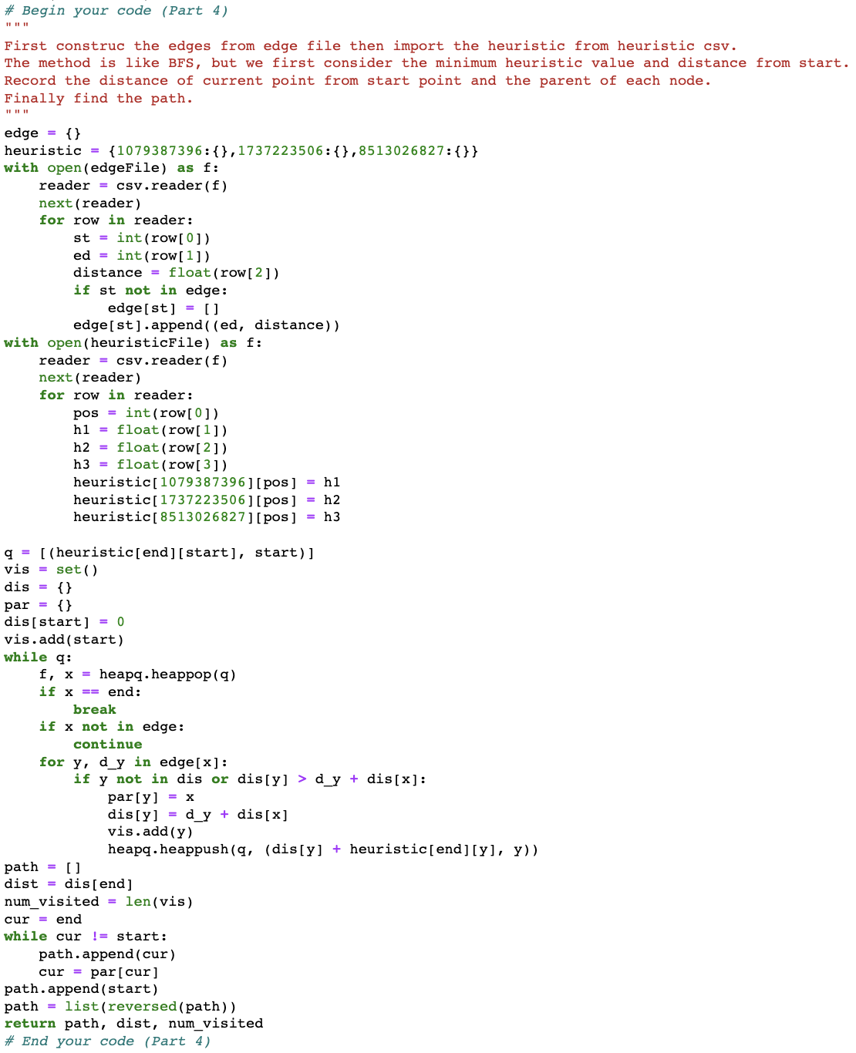
* **Part 6 A* Search with a different heuristic function  
  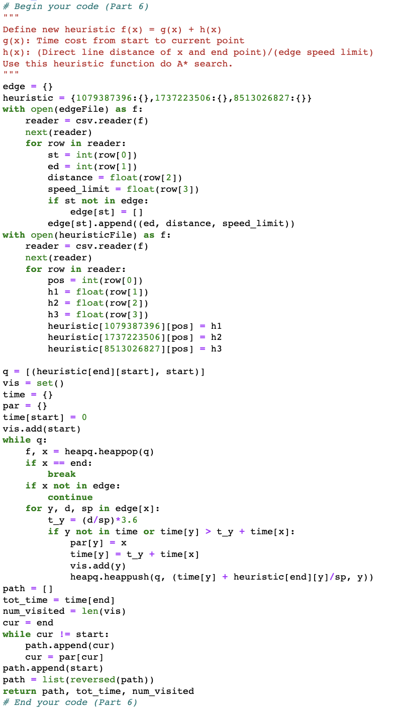**

**Part II. Results & Analysis (12%):**

* Test1: from National Yang Ming Chiao Tung University (ID: 2270143902) to Big City Shopping Mall (ID: 1079387396)  
  BFS:  
  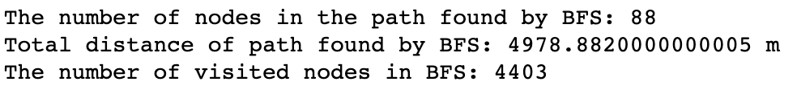  
  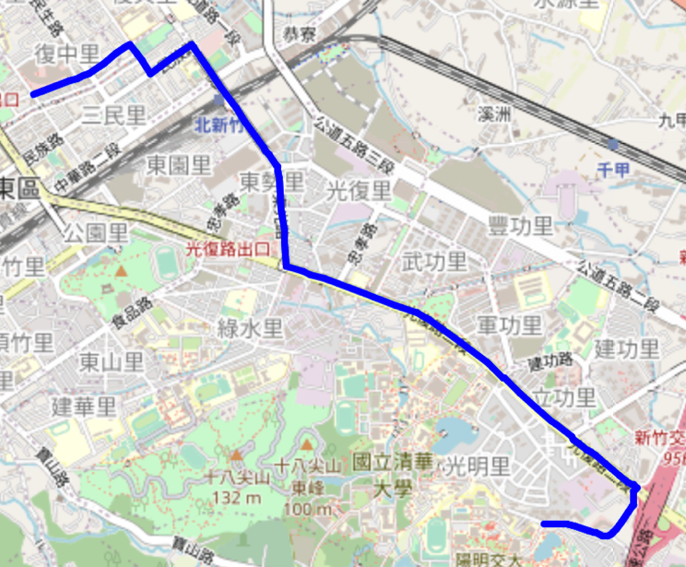  
  DFS (stack):  
  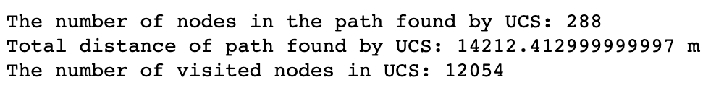  
  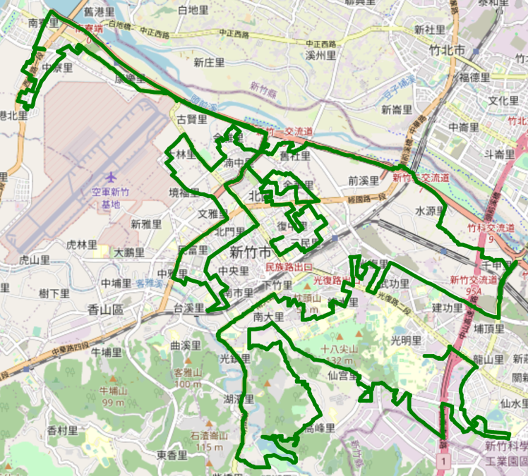  
  UCS:  
  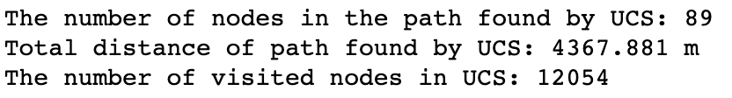  
  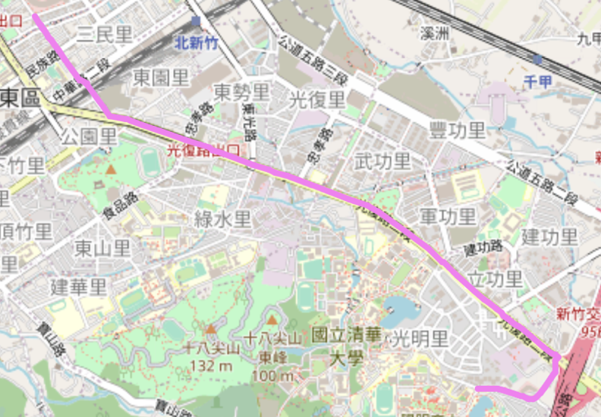  
  A* Search:  
  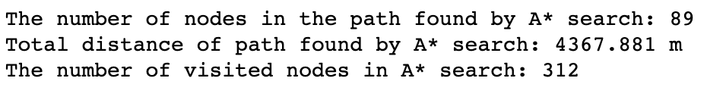  
  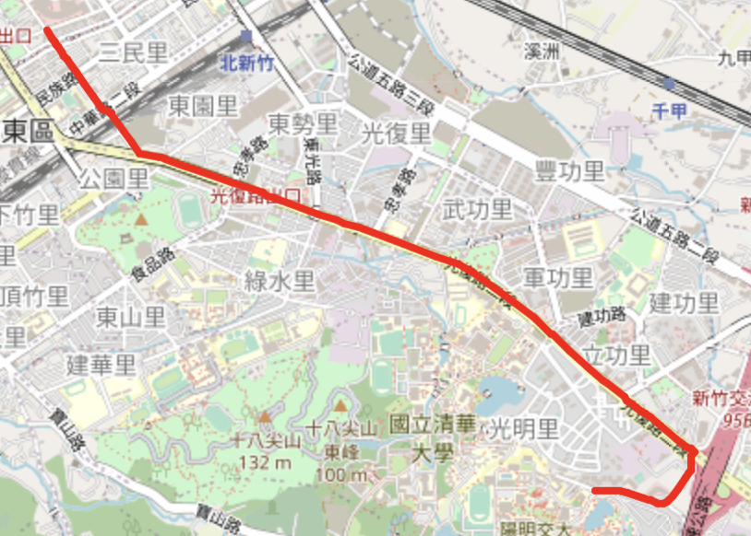  
  A* Search with another heuristic: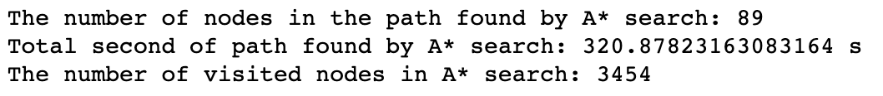  
  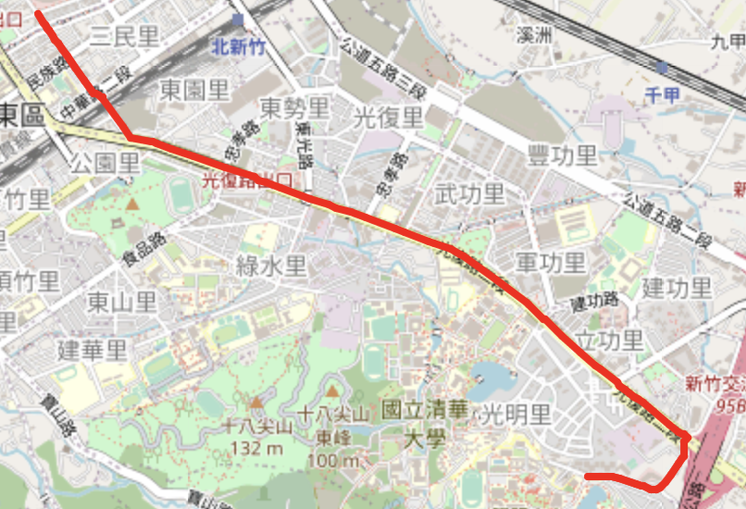
* Test2: from Hsinchu Zoo (ID: 426882161) to COSTCO Hsinchu Store (ID: 1737223506)  
  BFS:  
  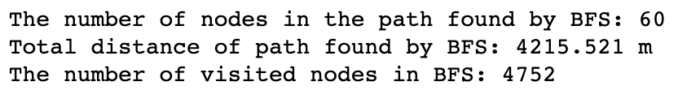  
  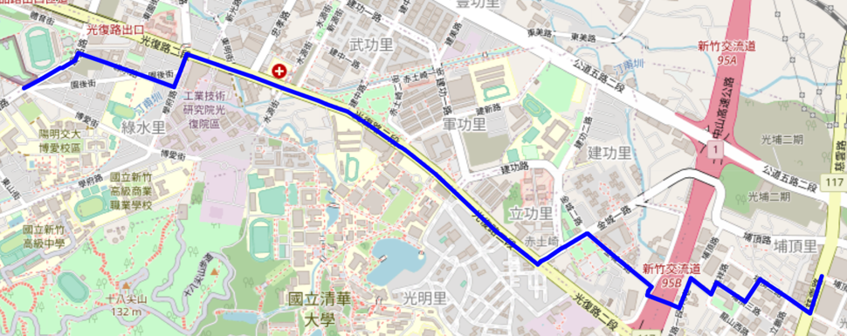  
  DFS:  
  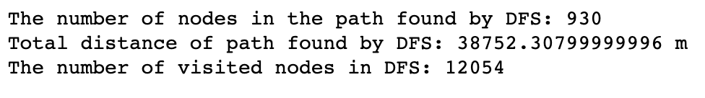  
  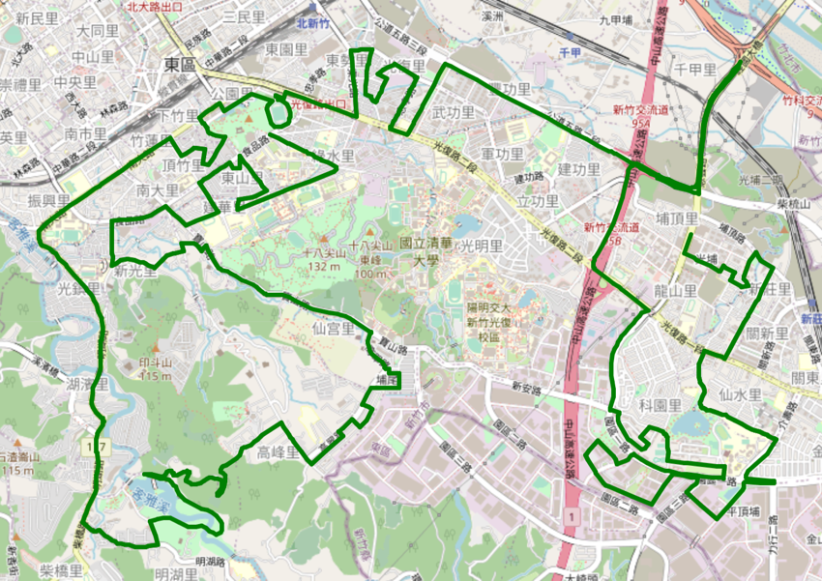  
  UCS:  
  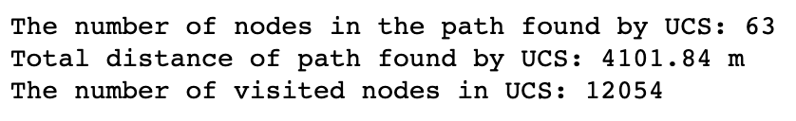  
  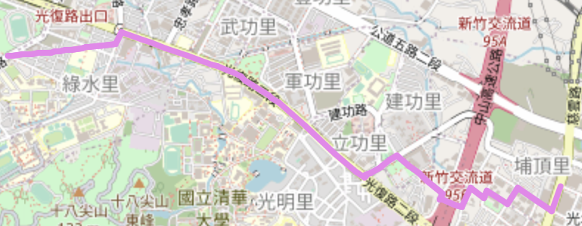  
  A* Search:  
  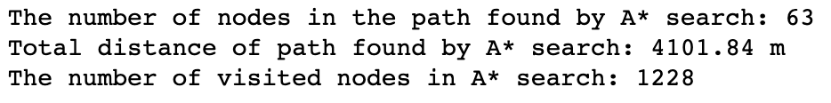  
  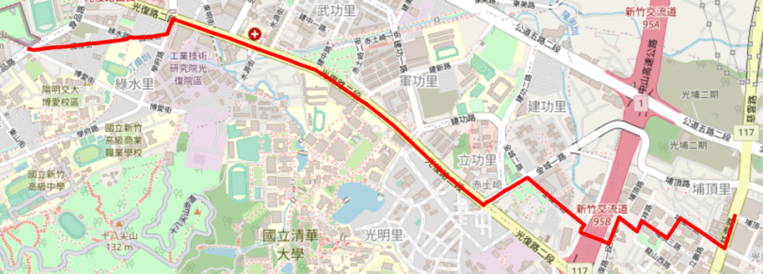  
  A* Search with another heuristic:  
  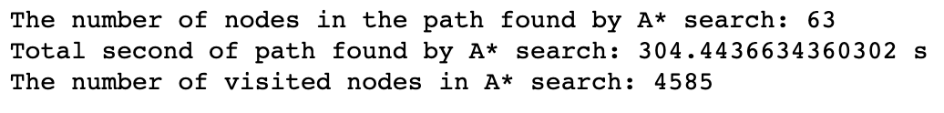  
  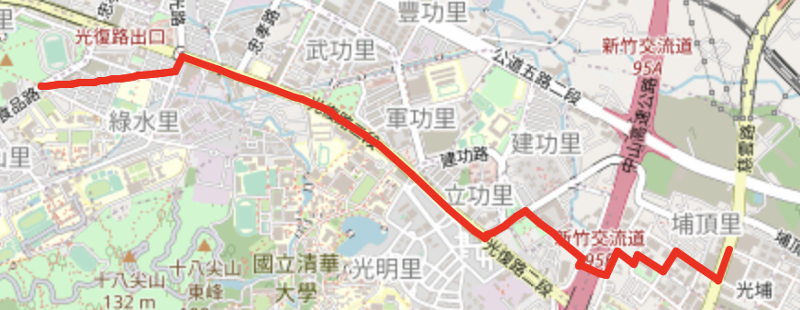
* Test3: from National Experimental High School At Hsinchu Science Park (ID: 1718165260) to Nanliao Fighing Port (ID: 8513026827)  
  BFS:  
  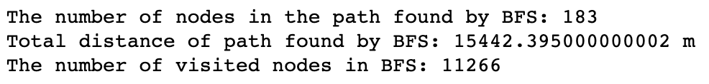  
  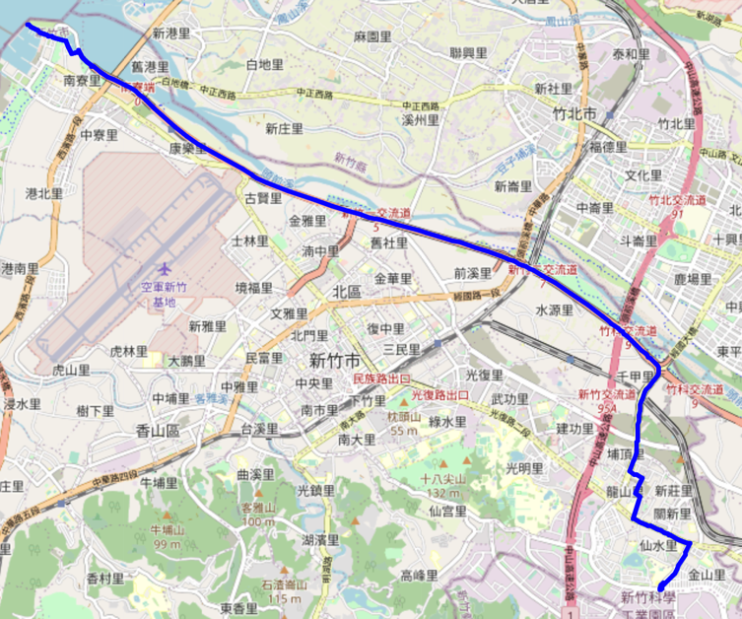  
  DFS:  
  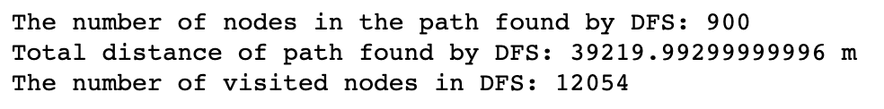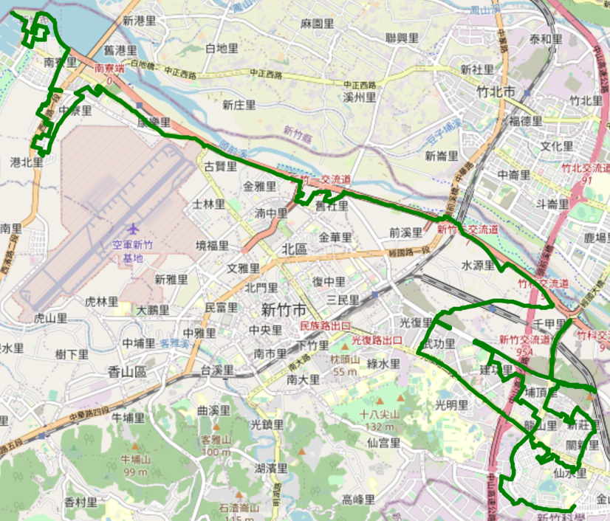  
  UCS:  
  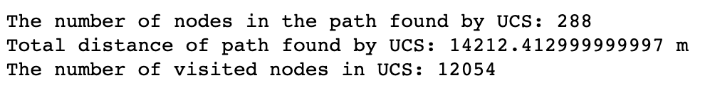  
  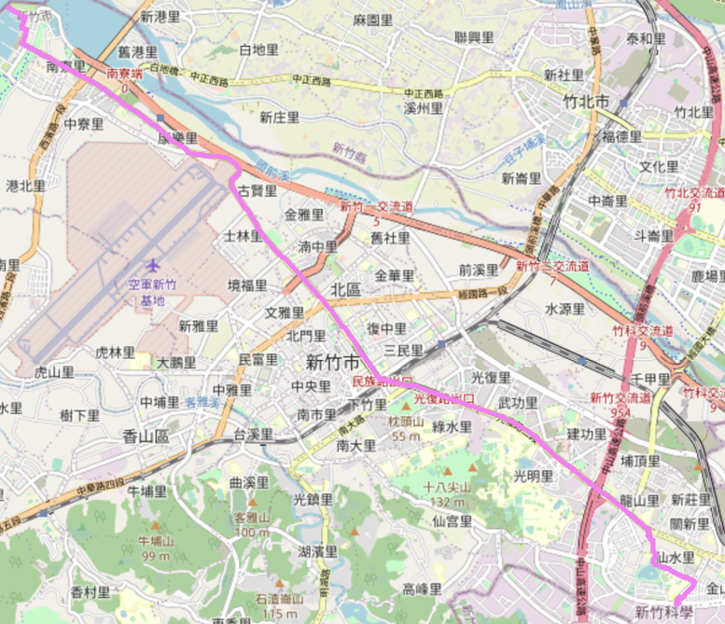  
  A* Search:  
  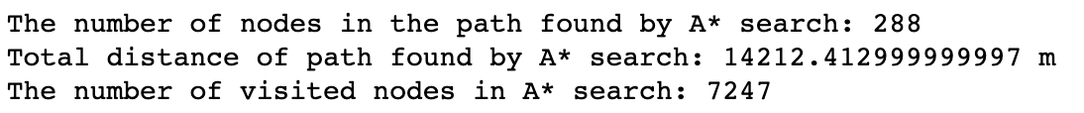  
  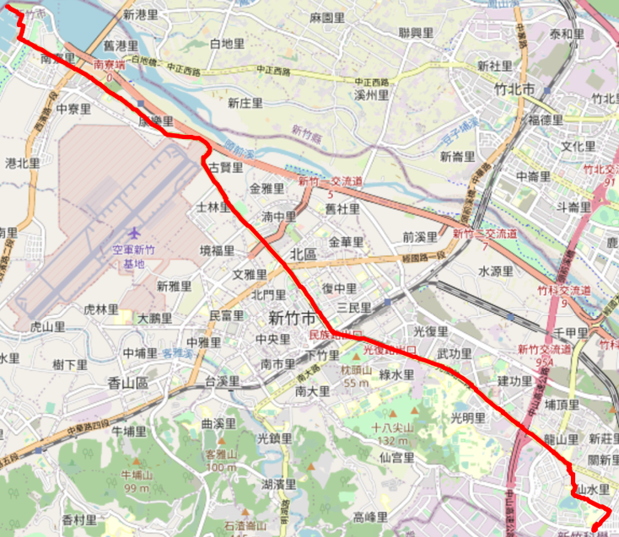  
  A* Search with another heuristic:  
  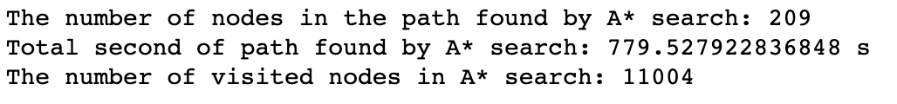  
  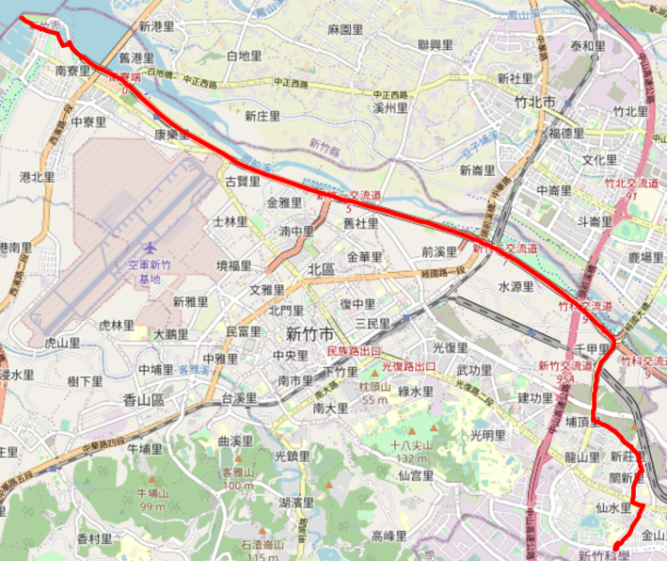

**Part III. Question Answering (12%):**

1. Please describe a problem you encountered and how you solved it.

Since I am not familiar with Python, I spent some time to implement classic algorithm with python. I usually implement BFS/DFS and dijkstra with C++ before. When I switch from C++ to Python, I need some time to get familiar with it.

1. Besides speed limit and distance, could you please come up with another attribute that is essential for route findingin the real world? Please explain the rationale.

The traffic light of every street and the average speed of every road. We also need to consider some road may be in renovation, so that we can not pass this road.

1. As mentioned in the introduction, a navigation system involves mapping, localization, and route finding. Please suggest possible solutions for **mapping** and **localization** components?

Mapping:

We can mappint the environment by object detection and lidar detection. We can equipment a car with some camera and sensor, then we drive the car to go around the street to collecting data. Thus we can mapping the environment we want.

Localization:

We can use GPS localization system or we can design our own such as using address of the street and road.

1. The estimated time of arrival (ETA) is one of the features of Uber Eats. To provide accurate estimates for users, Uber Eats needs to dynamically update ETA based on their mechanism. Please define a **dynamic heuristic** **equation** for ETA and explain the rationale of your design. Hint: You can consider meal prep time, delivery priority, multiple orders, etc.

ETA = $\sum_{k=0}^{n}{(mealpreptime_k+ distance_to_cutomers_k + traffic_issues_k)}$ for n orders ahead of current customer.

If delivery priority is true, then the ETA = $mealpreptime_k+ distance_to_cutomers_k + traffic_issues_k$

We can consider there are some orders ahead of us and meal preparing time and the distance from store to the place of customers and some traffic issues we should also take into consider.